**Bahria University, Islamabad Campus**

Department of Computer Sciences

Mid-Term Examination

Class /Section: BS CS (A,B)

**(Spring 2021 Semester)**

**Paper Type: Descriptive**

|  |  |
| --- | --- |
| Course: Data Communication and Networking Lab | Date: 23-04-2021 |
| Course Code: CEL 222 | Time: 90 Minutes |
| Faculty’s Name: Talha Naqash | Max Marks: 20 |

**INSTRUCTIONS:**

1. All questions are compulsory.
2. There are total three questions.
3. Submit only .doc or .docx file
4. Use the question paper to answer
5. Do not change the question number
6. Commands and answers should be written in **Blue**

Student’s Name: MALIK ZOHAIB MUSTAFA Enroll No: 01-134192-030

(USE CAPITAL LETTERS)

Class : BSCS Section: 4B

1. Write the difference between the CAT5 and CAT5e cables and write the procedure to construct EIA/TIA 568A straight through and cross over cable with the help of figure.

**Bandwidth:**

Bandwidth is the capacity of a system for carrying information so, in this sense, it is directly related to network support. Cat5e cables are rated at a frequency of 350 MHz, which is a significant increase on the Cat5 rating of a maximum frequency of 100 MHz A greater bandwidth allows for an increased capacity for carrying information, so it is this increase that allows Cat5e cables to support Gigabit Ethernet speeds.

**Network Speed:**

Cat5e cables offer a superior network performance compared to Cat5 cables. Cat5 cables will support network speeds of up to 10Mbps Ethernet and 100Mbps Fast Ethernet. As well as Ethernet and Fast Ethernet speeds, Cat5e cables are designed to support Gigabit speeds of up to 1000Mbps

**Interference Protection:**

Cat5e cables offer enhanced protection against crosstalk compared to standard Cat5 cables. Crosstalk is electrical interference that can occur when the signals from different wires and equipment affect the signals of others. Crosstalk reduces the speed at which cables can transmit information, resulting in a poor network performance. Although twisted pair cables have been designed to reduce interference, Cat5e cables offer an improvement in this regard, compared to Cat5 cables. This is because the wire pairs are more tightly twisted and they are protected by heavy-duty shielding, making them extremely durable.

**Part B:**

**Materials Required:**

1. Ethernet Cable

2. RJ 45 Connector

3. Crimping Tool

4. Wire Cutter

5. Cable Tester

Diagrams:

• Orange ,Orange-white ,Green ,Green-white , Blue ,Blue-white, Brown , Brown-white

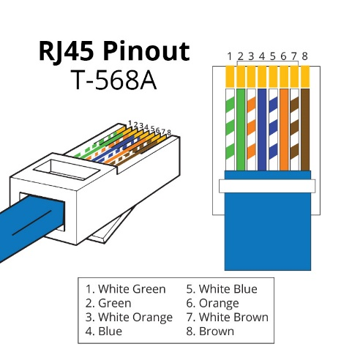

Note that pins 4, 5, 7, and 8 and the blue and brown pairs are not used in either standard. Two wires color-code standards apply: EIA/TIA 568A and EIA/TIA 568B.The codes are commonly depicted with RJ-45 jacks as follows (the view is from the front of the jacks). If we apply the 568A color code and show all eight wires, our pin-out looks like this:

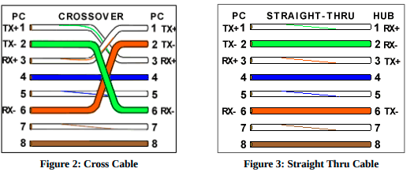

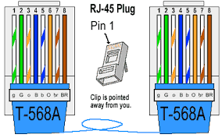

**Procedure :**

🡪We to measure out how long you want your cable to be, just so you don't have all this extra cable slack, or you don't make a cable too short, that would suck. Then, add 5 inches to that length so you have something to work with when terminating the cable ends.

🡪Using wire strippers ,strip about an inch off the cable, now you'll want to un-twist the cables all the way to the rubber shield. We want to make sure there is a few millimeters of copper exposed so they can make contact with the RJ-45 connector

🡪 Now we need to make sure each wire is in the correct position before you put on the RJ-45 connector. For straight cable by using 568A standard it should be white-orange, orange, white green, blue, white-blue, green, white-brown, brown, and this should be from look at the top of the connector.

🡪Put on the RJ-45 connector, and make sure the copper ends are making contact with the metal plates in the RJ-45 connector, if they aren't go back and try organizing the wires so they all connect.

🡪 Put it in the crimping tool and crimp it, now you have one end terminated.

🡪 For the other end repeat steps 2-6.

🡪 Plug your Ethernet cable into the tester and see if it all the lights light up green, if they do then you're good, and you can get to making your other cables, if they don't you'll have to cut off the RJ-45 connector and determinate your ends with a new connector

1. Answer the following questions. (**1*5 Marks)**
   1. How many bytes does each Class of IP address use to represent network and host IDs?

|  |  |  |
| --- | --- | --- |
| IP Address Class | Bytes Used By Network ID | Bytes Used By Host ID |
| CLASS A | 1 | 3 |
| CLASS B | 2 | 2 |
| CLASS C | 3 | 1 |
| CLASS D | - | - |
| CLASS E | - | - |

* 1. How many numbers of networks and hosts can be represented using the IP address Class es?

|  |  |  |  |
| --- | --- | --- | --- |
| Class | Range of First Octet | Possible Networks | Hosts Per Network |
| CLASS A | 0 to 126 | 127 | 16,777,214 |
| CLASS B | 128 to 191 | 16,384 | 65,534 |
| CLASS C | 192 to 223 | 2,097,152 | 254 |

* 1. What is the possible range of IP addresses for the different Class es?

|  |  |
| --- | --- |
| IP Address | RANGE |
| CLASS A | 0.0.0.0 to 127.255.255.255 |
| CLASS B | 128.0.0.0 to 191.255.255.255 |
| CLASS C | 192.0.0.0 to 223.255.255.255 |
| CLASS D | 224.0.0.0 to 239.255.255.255 |
| CLASS E | 240.0.0.0 to 247.255.255.255 |

* 1. What are the different memories used in a CISCO router?

|  |
| --- |
| 🡪NVRAM 🡪It Has startup configuration file      🡪DRAM🡪 It Has configuration file that is being executed      🡪Flash Memory🡪 It Has the Cisco IOS.     🡪ROM |

* 1. How to decide which Class of IP address to use for a particular network?

|  |
| --- |
| The Class of IP address to use for a particular network depends on the maximum number of hosts in the network. For example, if the maximum number of hosts in a network will be less than 254 hosts, then a Class C IP address can be used for the network. If the maximum number of hosts in a network will be greater than 254 hosts but less than 65534, then a Class B network can be used. |

1. **Connect five computers through switch with each other exactly according to figure given below and share all the required screenshot to understand the procedure.** (**4+4+2 Marks)**
   1. **Assign static private IP addresses of Class A to all computers.**

* 1. **Ping all computers with each other (1,2), (1,3), (1,4), (1,5), (2,1), (2,3), (2,4), (2,5), (3,1), (3,2), (3,4), (3,5), (4,1), (4,2), (4,3), (4,5).**
  2. **Share the desktop through switch.**

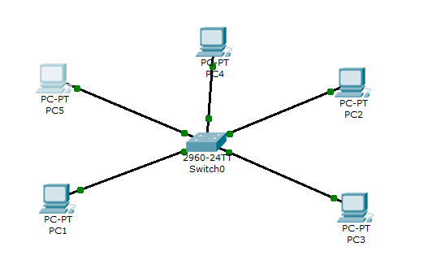

Figure 1: Question 3 Scenario

**Answer:**

|  |
| --- |
| Static IP OF PCS            Ping From Pc 1: |
| PC 2:      Similarly For PC3 we will use Pings  PING 14.2.2.1  PING 14.2.2.2  PING 14.2.2.4  PING 14.2.2.5  Similarly For PC4 we will use Pings  PING 14.2.2.1  PING 14.2.2.2  PING 14.2.2.3  PING 14.2.2.4  Similarly For PC5 we will use Pings  PING 14.2.2.1  PING 14.2.2.2  PING 14.2.2.3  PING 14.2.2.4 |

Part E:

